|  |  |
| --- | --- |
| **Take Home Case** | Description: LogoBINUS-University |
| *Web Design* |
| **Periode Berlaku** Semester Ganjil 2022/2023  ***Valid on*** *Odd Semester Year 2022/2023* | **Software Laboratory Center**  **Assistant Recruitment 23-1** |

## Materi

*Material*

* Website Prototype
* HTML
* CSS
* Javascript
* jQuery
* HTML5

## Soal

*Case*

**JeTe Knight**

**JeTe Knight** is an action-adventure video game developed and published by independent studio Team Amigo. It was released in 2017 for Microsoft Windows, macOS, and Linux, and was later released for the Nintendo Switch, PlayStation 4, and Xbox One.

In the game, players control a small, silent knight on a journey to uncover the mysteries of the abandoned insect kingdom of Hallownest. You as a intern on Amigo Team studio asked to make a demo game to the introduction **JeTe Knight** to the worldwide.

* **Navigation Bar**
* This navigation bar contains of 3 menus, **home**, **how to play**, **play for free**.
* If the **home**, and **how to play** menu get hovered, **underline text** will be showed up.
* Please make sure this **navigation bar** in exists in all page.

1. If userclickthe **home**, then:
   * Redirect to the **home page**
2. If userclickthe **how to play**, then:
   * Open the **modal**
3. If userclickthe **play for free**, then:
   * Redirect to the **game page**



* **Footer**
* This footer contains of 3 external link, **discord**, **facebook**, **twitter**,and **the footer text**. Please make sure if user click the link they will redirected to the external link.
* The external link must be upward when be hovered.
* Please make sure this **navigation bar** in exists in all page.



* **Home Page**
* This home page contains of 7 sections, which are **Jumbotron**, **Description**, **Video Intro**, **News, Main Character, All Bosses, Official Soundtrack**.

1. If usersee the **jumbotron**, then:
   1. Display the **navigation bar** on the top of the jumbotron.
   2. Display **jumbotron background** as a video from the assets.
   3. Display **logo** on the center of jumbotron.
   4. Display **latest news** on the bottom of jumbotron, the **latest news** consists of **date, title**, and **gray line**. If the user hovers on the **latest news card,** then the **gray line** will be changed to **red line** and the card will be **larger**.
   5. You need to create a **bottom black gradient** for the **jumbotron and the main background.**

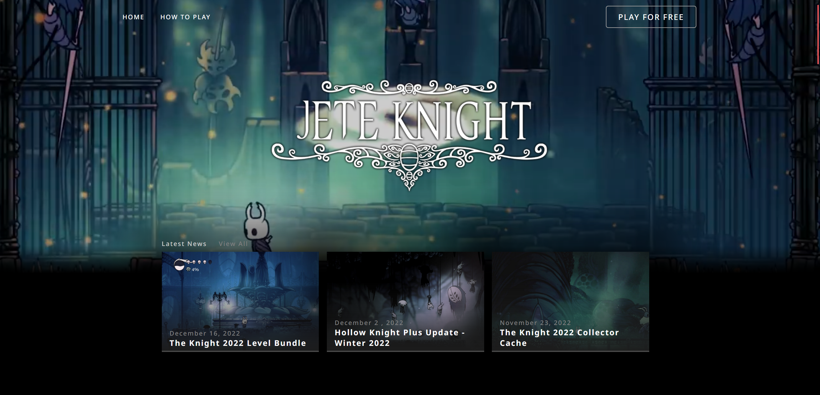

Figure 1. Jumbotron

1. If usersee the **description**, then:
   * Display a **card** **carousel** consist of **description title**, **description text**, and **description image**.Add a **three red circle** indicator to indicate current carousel index.
   * Don’t forget to add left and right arrows to change the card carousel.

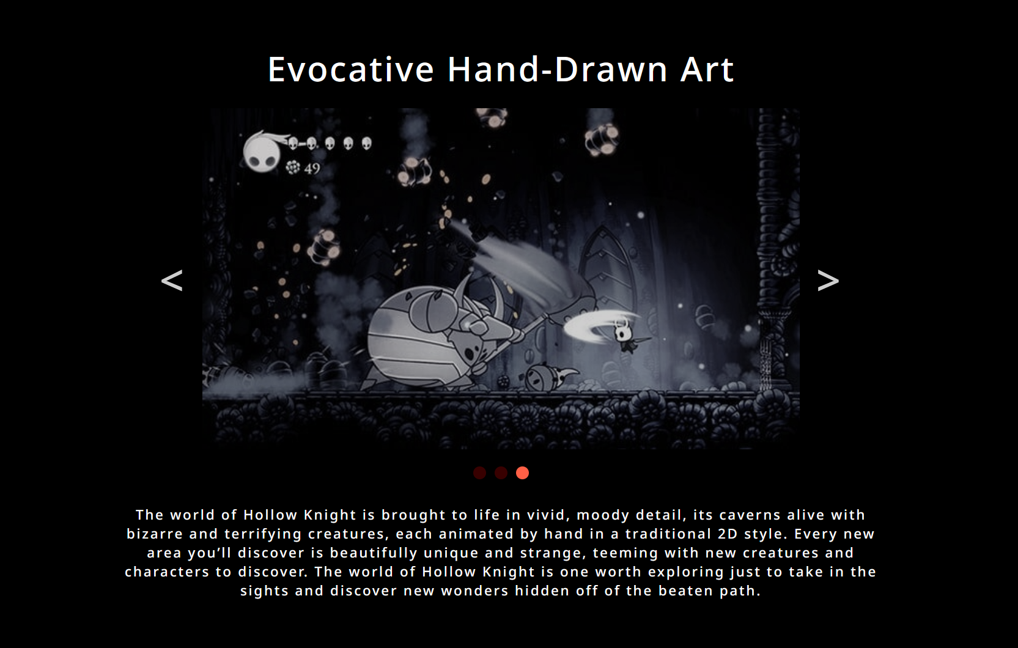

1. If usersee the **video intro**, then:
   * Display a **youtube video** using **iframe** from the current link
     + https://www.youtube.com/watch?v=JuP47fRBsWg

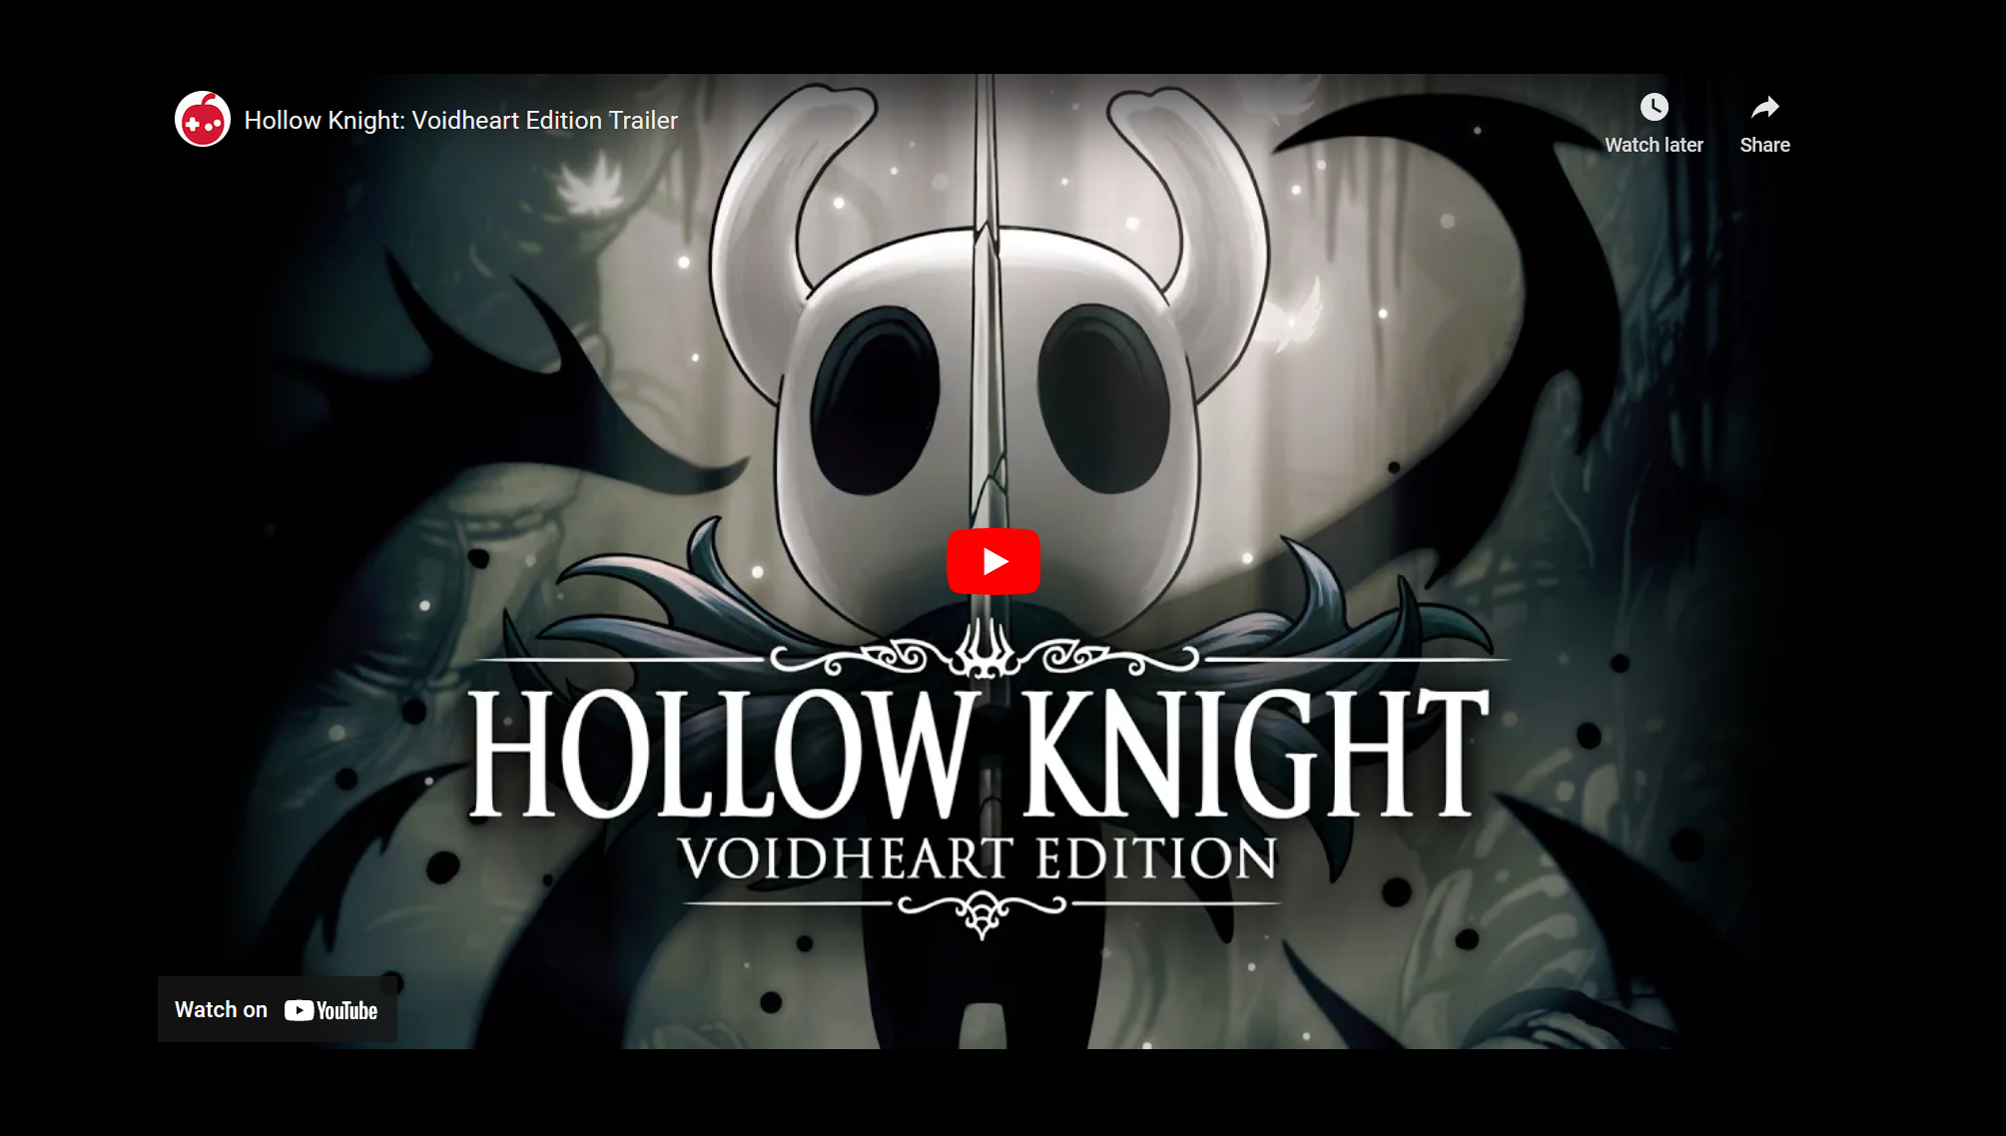

1. If usersee the **news**, then:
   * Display a **4 news card,** each news card contains of **news title**, **news text**, **news image**.

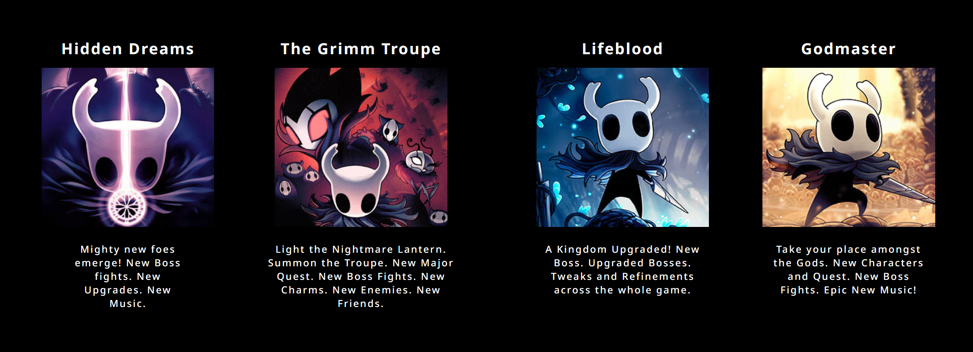

1. If usersee the **main character**, then:
   * Display **main character image**, **title**, **description**, and button to links to external link (**wikipedia)**

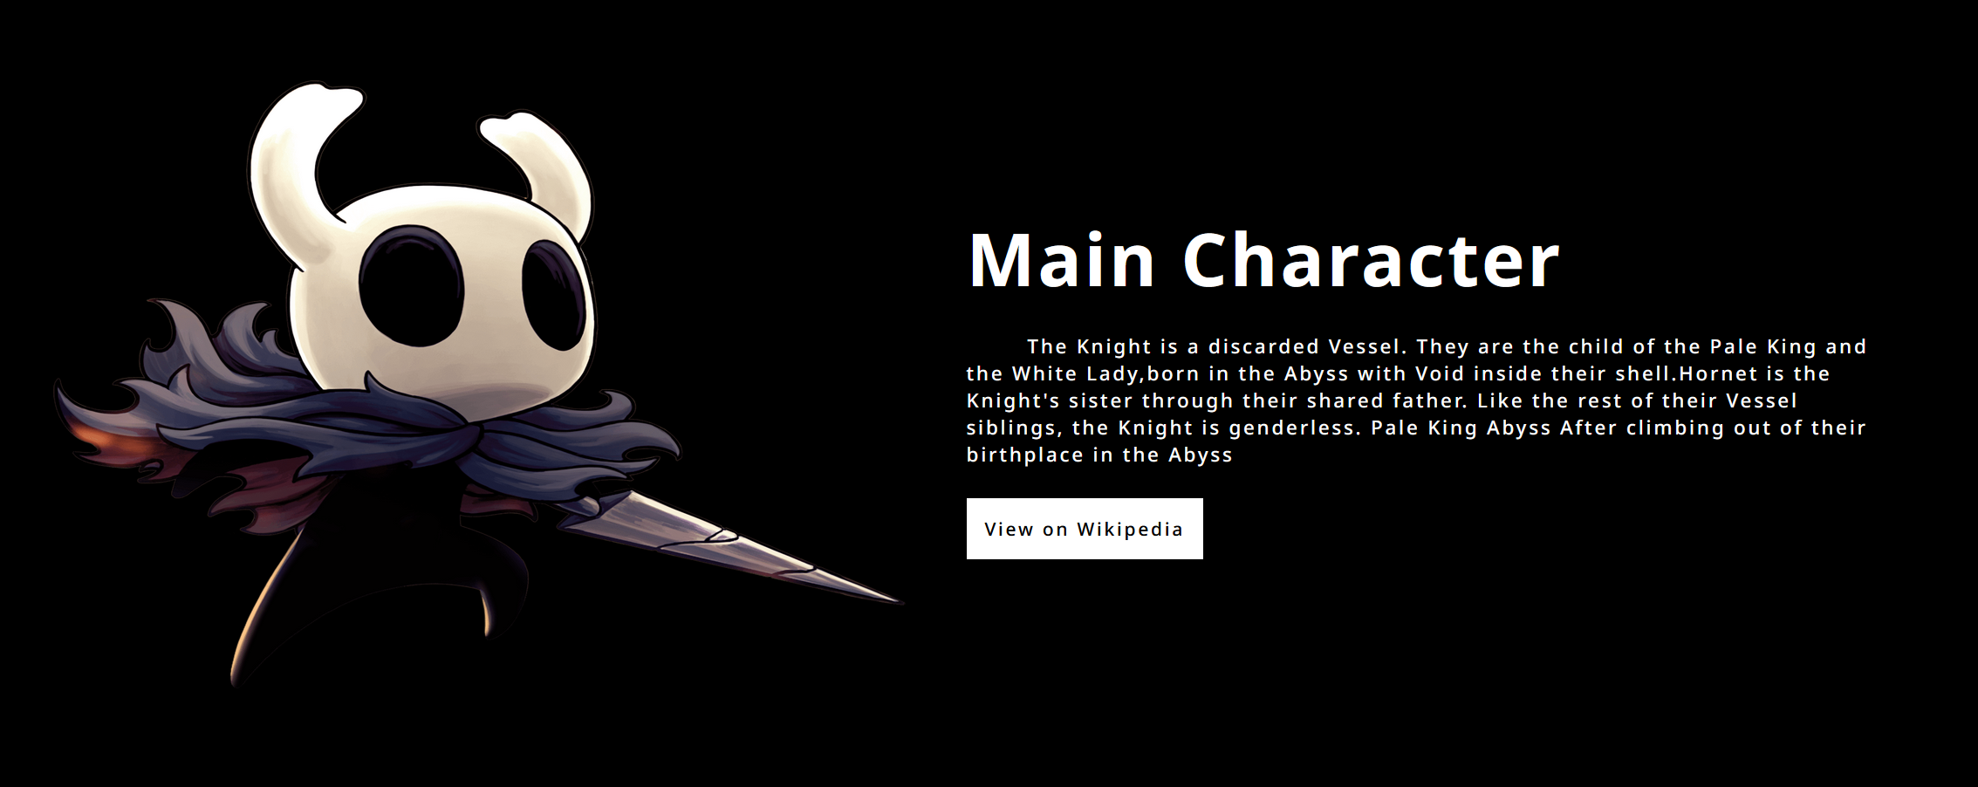

1. If usersee the **all** **bosses**, then:
   * Display **all boss’s** cards in the 4 rows. Each card contains a boss image, and a boss title. Boss Title only shows if the card is hovered.
   * Don’t forget to make an **animation** where the **odd row** must moving from the right to left and the even row must moving from the left to right.

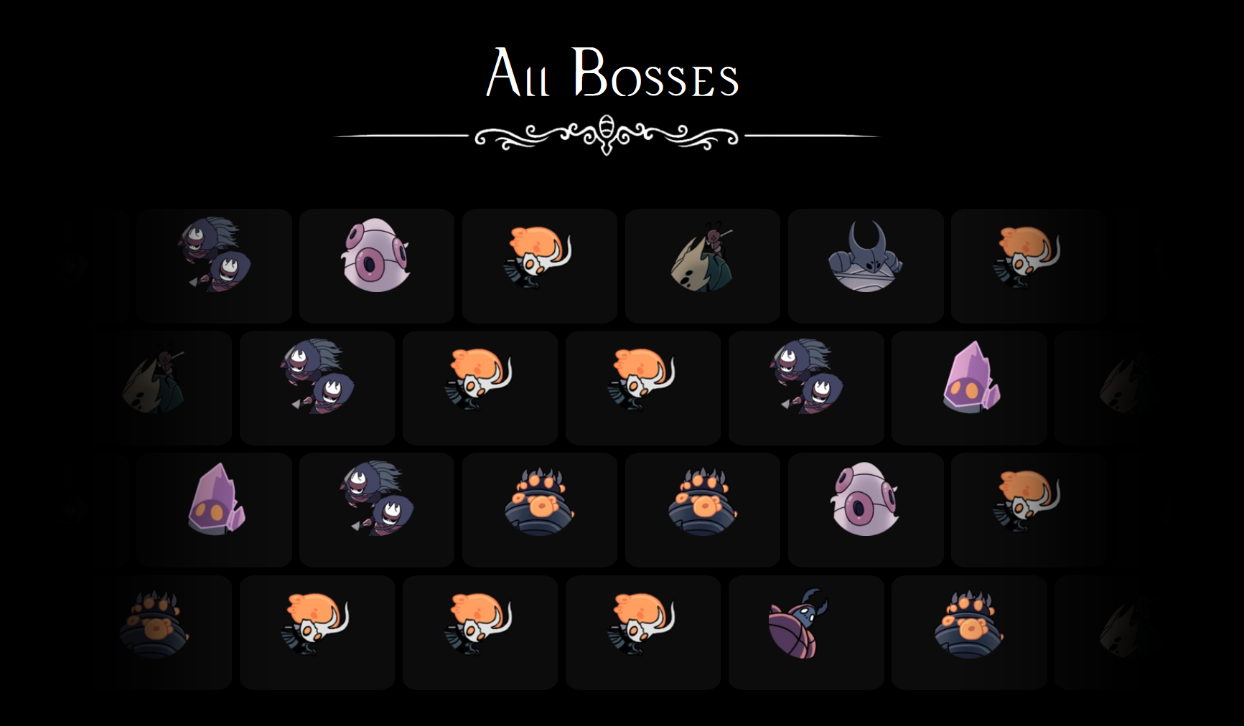

1. If usersee the **Official Soundtrack**, then:
   * On the left side of the container, display **title**, **description**, and a **button** to download the soundtrack. You can freely choose any audio asset in the folder to be downloaded.
   * On the right side of the container, displays the **soundtrack image**.

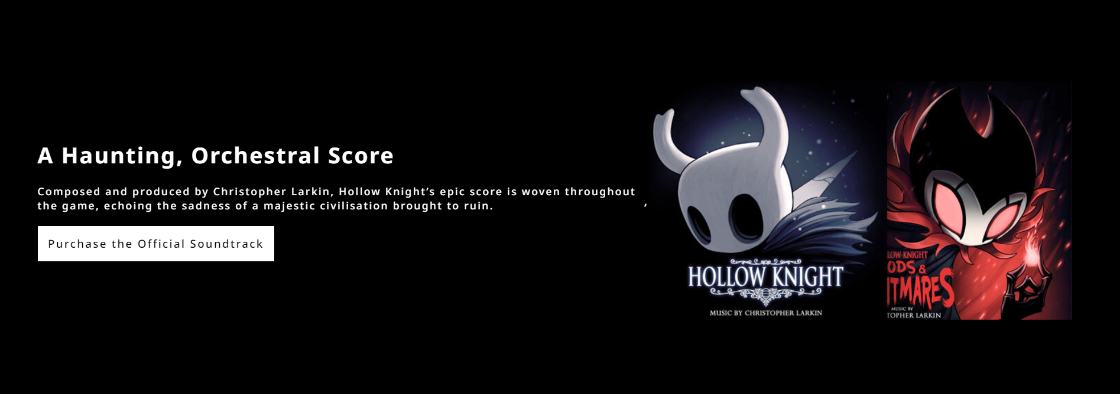

* **Modal**
* This section contain of 2 pages, **how to play**, and **keymap**.
* Display **current page** and the **max page** divided by **‘/’**.
* Display **X** Button to close the modal.
* Display **right**, and **left** cursor to change page in the modal.

1. If usershow **how to play** page, then:
   * Display all instruction text in the line using **<ul>** and **<li>**.
   * You need to add **‘#’** to the instruction text using **before selector css**.

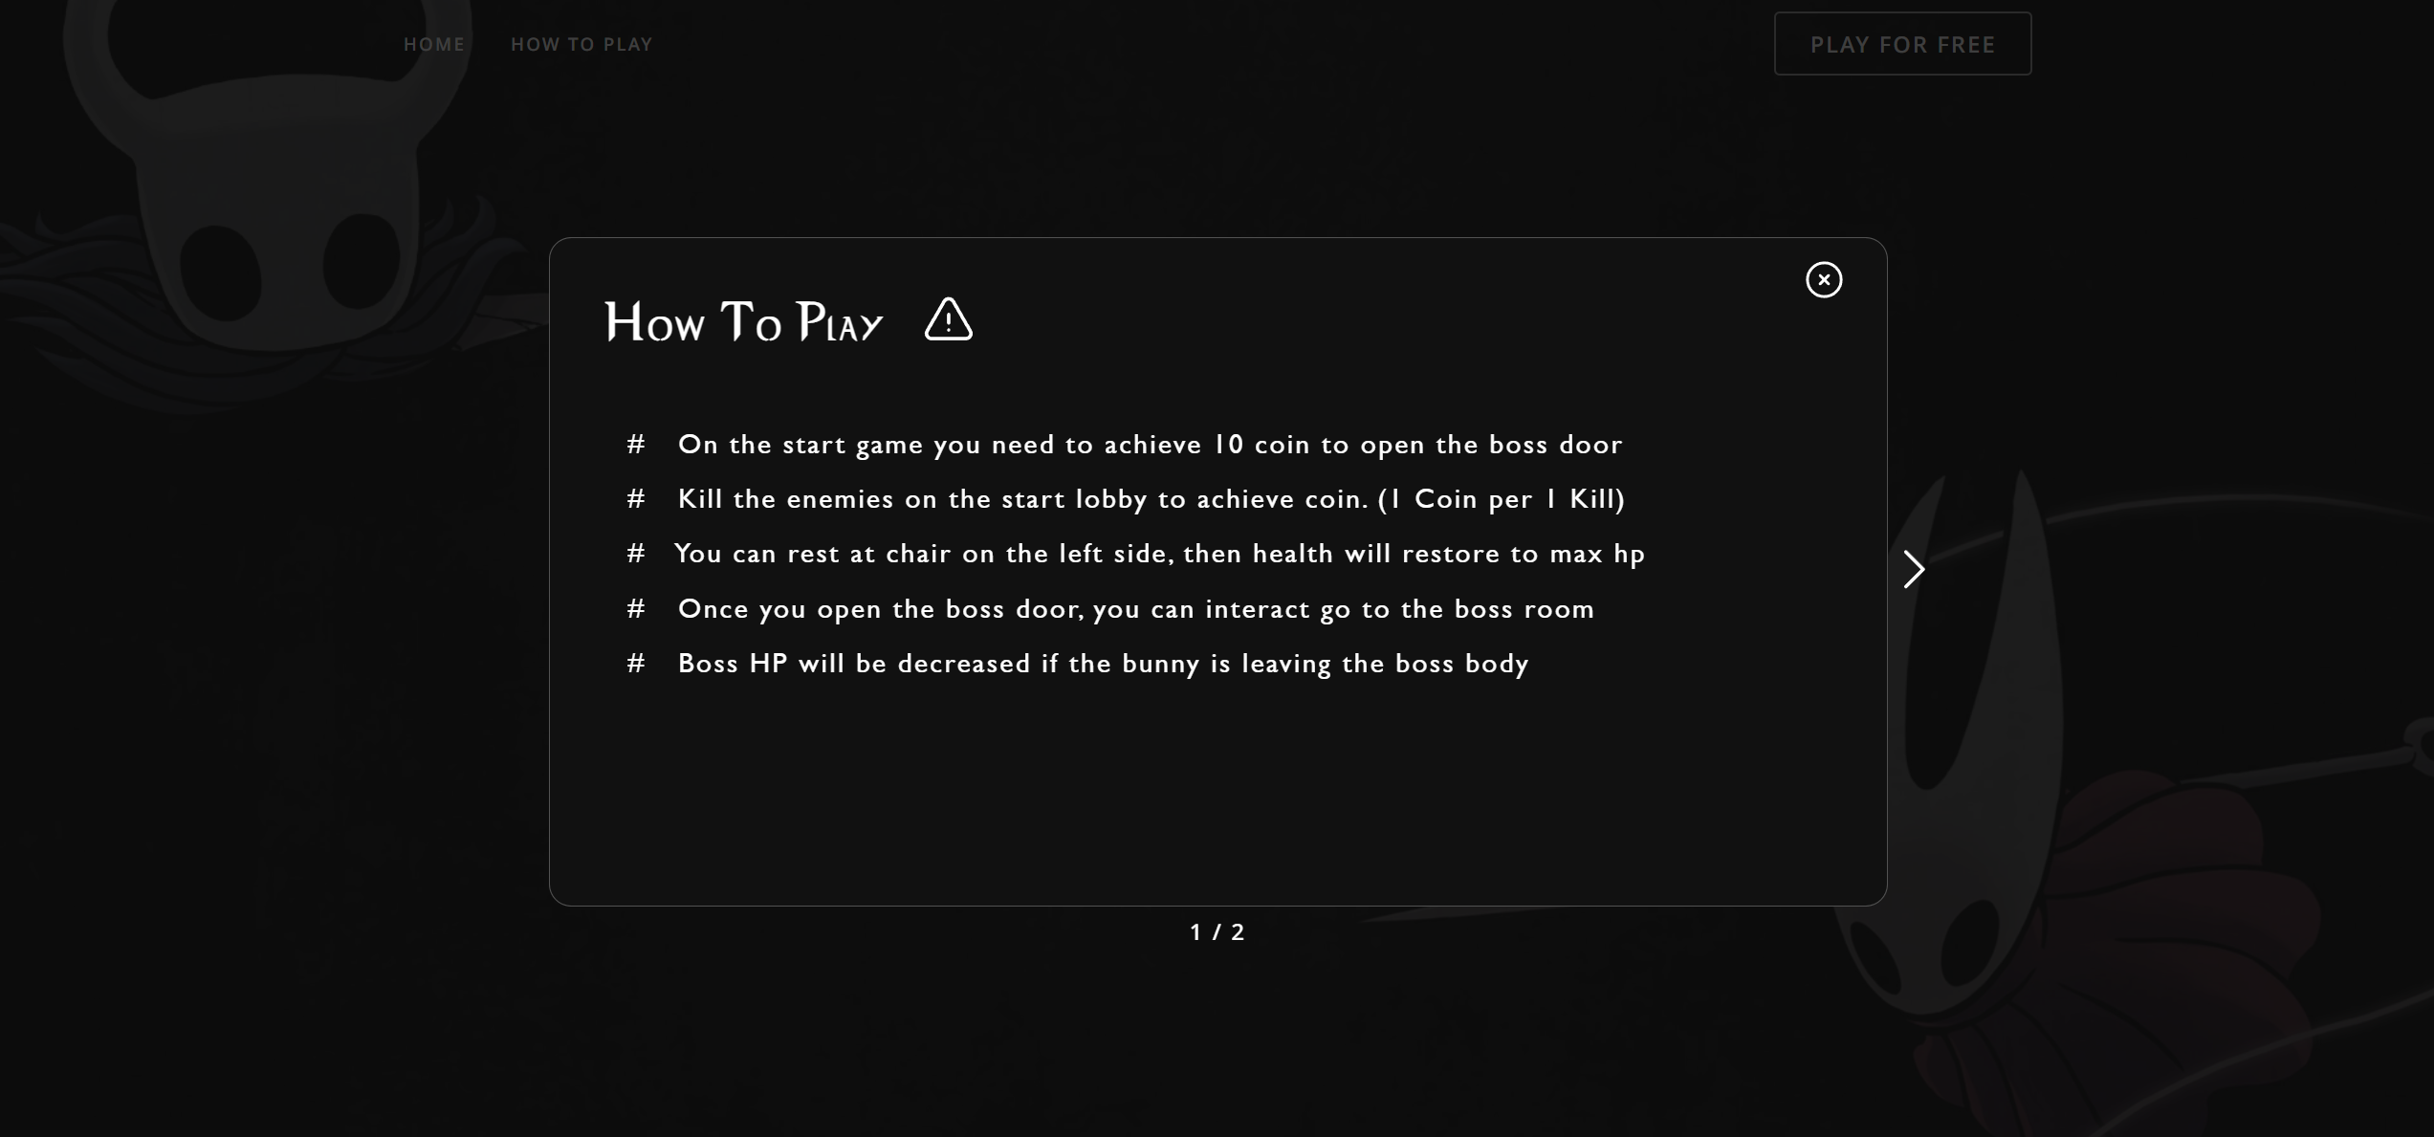

1. If user show **keyboard** **mapping** page, then :
   * Display a keyboard mapping **header**.
   * Display a **virtual keyboard**. Please color the **usefull key differently then others**.
   * If the user **press a key in there keyboards** and the **key is exists in the virtual keyboard**, **then darken the color** of the key by 300ms.
   * If the user press the **usefull key** then display **the key description on the game**.

|  |  |
| --- | --- |
| **Esc** | Pause the game |
| **E** | Interact (used when go to the boss or the rest) |
| **S** | Player Dash |
| **F** | Active Fullscreen Mode |
| **Z** | Player Jump |
| **X** | Player Attack |
| **Space** | Interact (used when go to the boss or the rest) |
| **Arrow Up** | Player Jump |
| **Arrow Left** | Player Move Left |
| **Arrow Right** | Player Move Right |

* **Game Page**
* Display the background given on the asset as the background of **game page**.
* In the center of the page display the **game canvas** of the **demo game**.

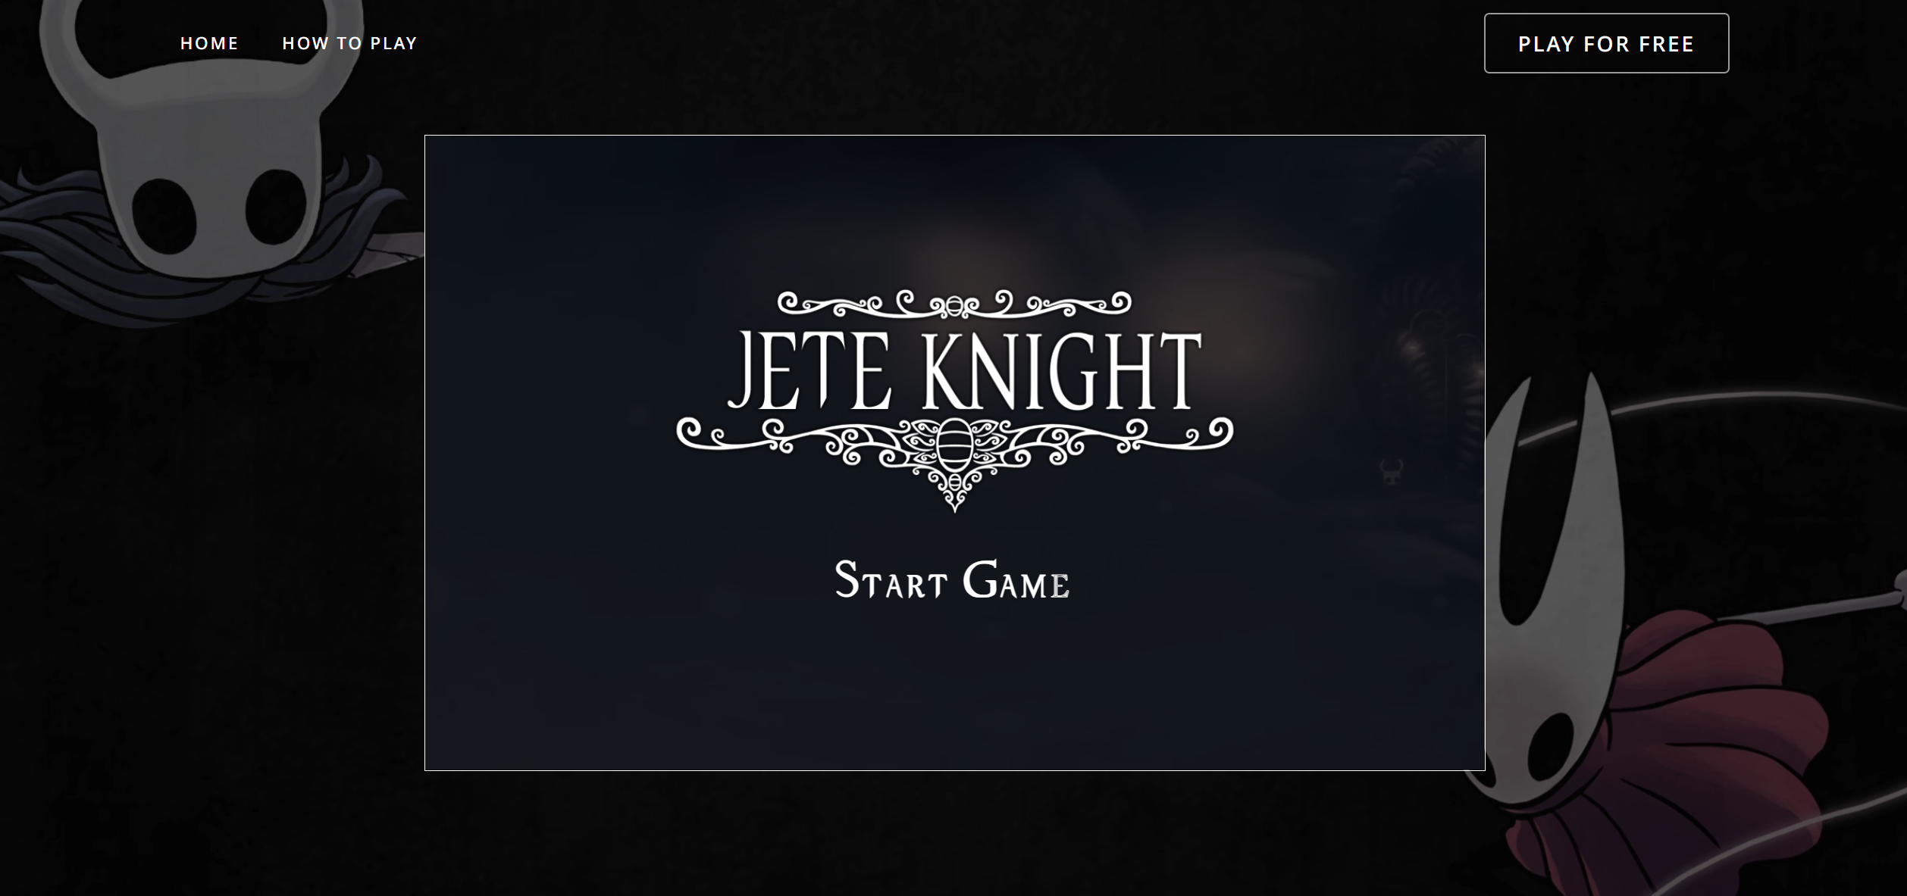

* **Demo Game**
* The game will be written using **HTML5 Canvas**.
* You should use **game developing concepts** and best practices such as main game loop, state,or any pattern that the game needs.
* You must calculate your own **delta times**.
* All the movement in the game needs to times by **delta times**, because it will made the game frame independent.
* Use **object-oriented programming concepts** to aid you in your development process.
* The following Demo Game consist of :

1. Main Menu
   * Display **logo** and **start video**.
   * Display **Start Game** at the bottom of the logo.
   * If user click **start game** then the game will be start.

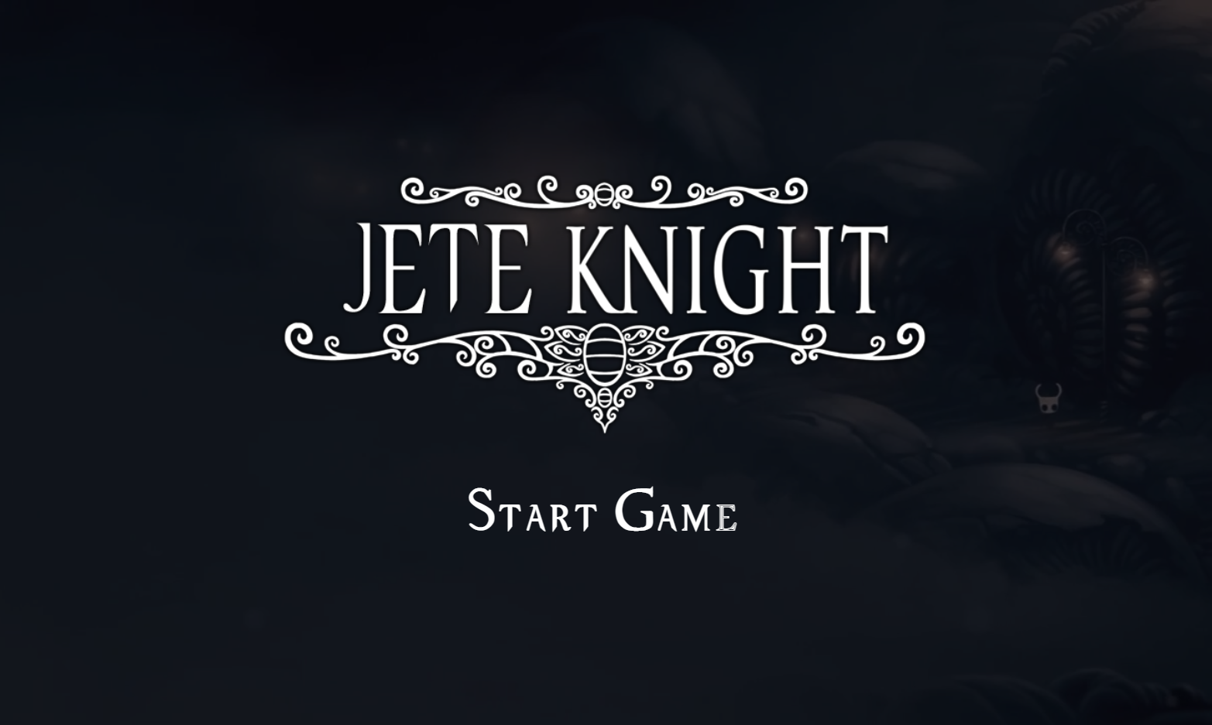

1. Home Game
   * When the game has started, play the home.mp3 on the asset folder.
   * Start to calculate the FPS (Frames Per Second). and show it at the right of the game.
   * Display main background.
   * Display the ground.
   * Display the foreground.
   * Display and Render the main character in the home.
   * Display three platform.
   * Display UI interface for health & point.
   * Display boss door at the right of the game.
   * Every 10 seconds generate 2 crawlids and 1 vengefly. For reduce so many crawlid and vengefly validates if the crawlid and vengefly is more than 10, then don’t generate it.

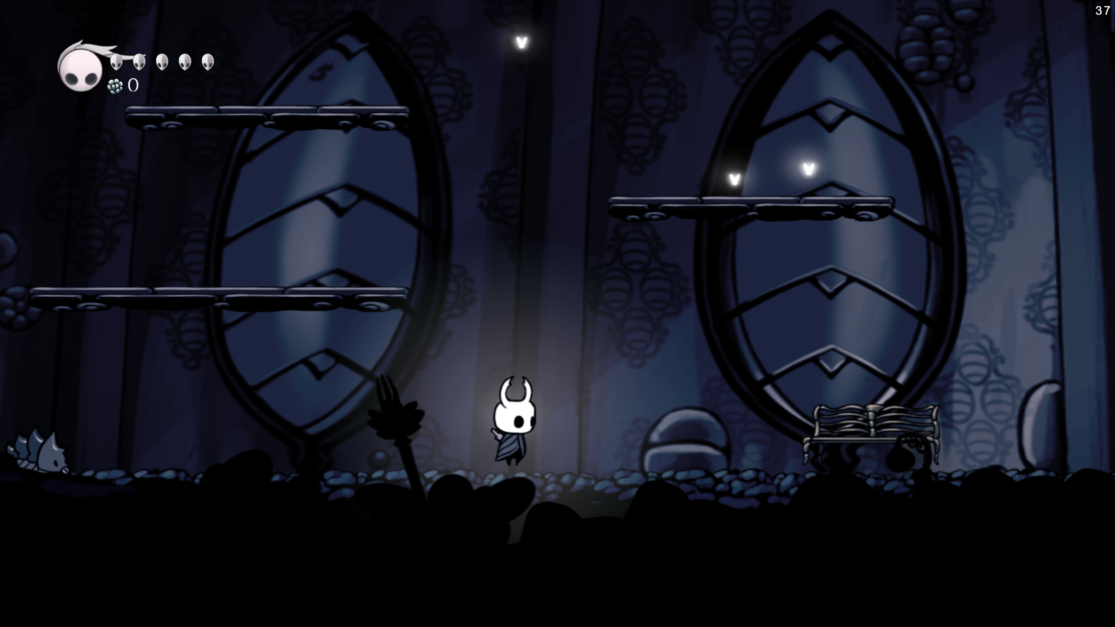

1. Player
   * Below are the **animations** that will be used :

|  |  |
| --- | --- |
| **Idle** | /Textures/Cuphead/Idle |
| **Running** | /Textures/Cuphead/Run/Normal |
| **Running Turning** | /Textures/Cuphead/Run/Normal |
| **Ducking** | /Textures/Cuphead/Duck/Idle |
| **Ducking Idle** | /Textures/Cuphead/Duck/Idle |
| **Ducking Turning** | /Textures/Cuphead/Duck/Idle |

* + Below are the **animations** that will be used :

|  |  |
| --- | --- |
| **Idle** | /Textures/Cuphead/Idle |
| **Running** | /Textures/Cuphead/Run/Normal |
| **Running Turning** | /Textures/Cuphead/Run/Normal |
| **Ducking** | /Textures/Cuphead/Duck/Idle |
| **Ducking Idle** | /Textures/Cuphead/Duck/Idle |
| **Ducking Turning** | /Textures/Cuphead/Duck/Idle |

* + Below player will have **different states** depending on **what it is currently doing**. The states are listed as follow:
    - Dashing
      * **Character** will enter a **dashing state** if the player presses the **s button**.
      * When character is dashing, play the dashing animation.
      * While dashing, character will have brief invicibility.
      * The dashing will be a top priority, which means the player cannot do other actions that will cancel the dashing.
      * Play Dash sound when character is dashing
    - Attack
      * Character will enter attack state if the player presses the X button.
      * When character is attacking, play the attacking animation. There are 2 attack animation that provided. You need to use two of them periodically.
      * When attacking, make a splash particle in front of the character is heading. Use the splash particle that provided to make an animations.
    - Hit
      * The game will pause for **0.5** **seconds** if it **collides** with the **enemy**.
      * Character will enter **hit** **state** for **3 seconds** if it **collides** with the **enemy**. And don’t forget to **render a hit particle** effect that provided.
      * In the **hit state,** please make sure the character won’t be hitted again **(invicible)**.
      * Character’s HP will be decreased by one if it got hit by the **enemy**.
      * Display character fade in & fade out periodicly when in the **hit state**.
    - Jumping
      * Character will enter **jumping state** if the player presses the **Z button**.
      * When character **is in the air**, play the **jumping animation** that provided.
      * When character **jumps**, play the **jumping sound** that provided.

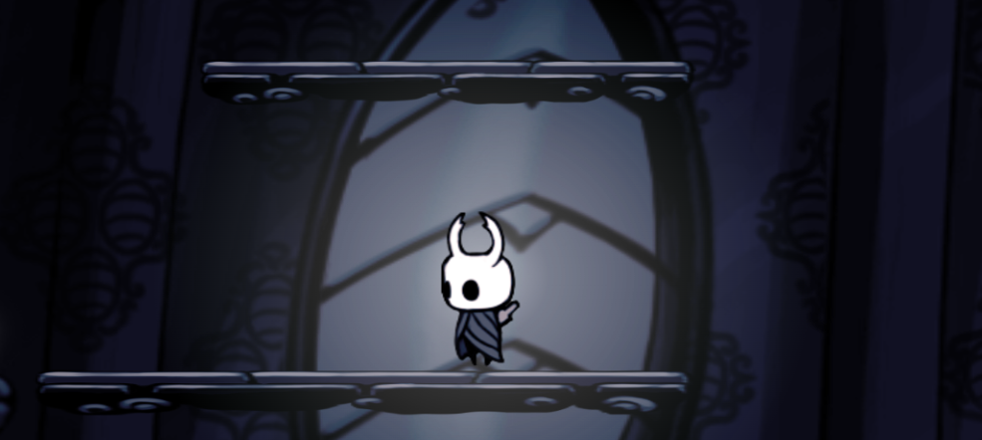

1. Enemy

Please run the EXE file to see the sample program.